Example Task:
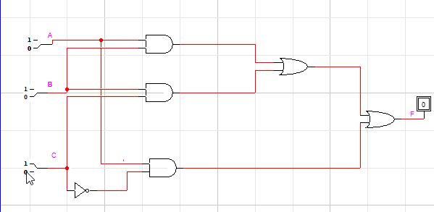
Timing signals:
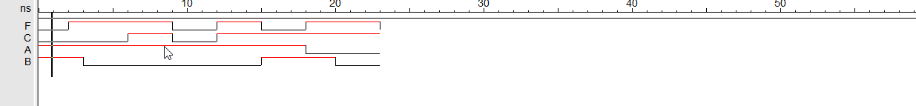

Example Logic Expression:
Z=(A.B+B.C)+(A.C̅)
A | B | C | A.B | B.C | A. C̅ | A.B+B.C | Z
0 | 0 | 0 | 0 | 0 | 0 | 0 | 0
1 | 0 | 0 | 0 | 0 | 1 | 0 | 1
0 | 1 | 0 | 0 | 0 | 0 | 0 | 0
1 | 1 | 0 | 1 | 0 | 1 | 1 | 1
0 | 0 | 1 | 0 | 0 | 0 | 0 | 0
1 | 0 | 1 | 0 | 0 | 0 | 0 | 0
0 | 1 | 1 | 0 | 1 | 0 | 1 | 1
1 | 1 | 1 | 1 | 1 | 1 | 1 | 1

Task1 :
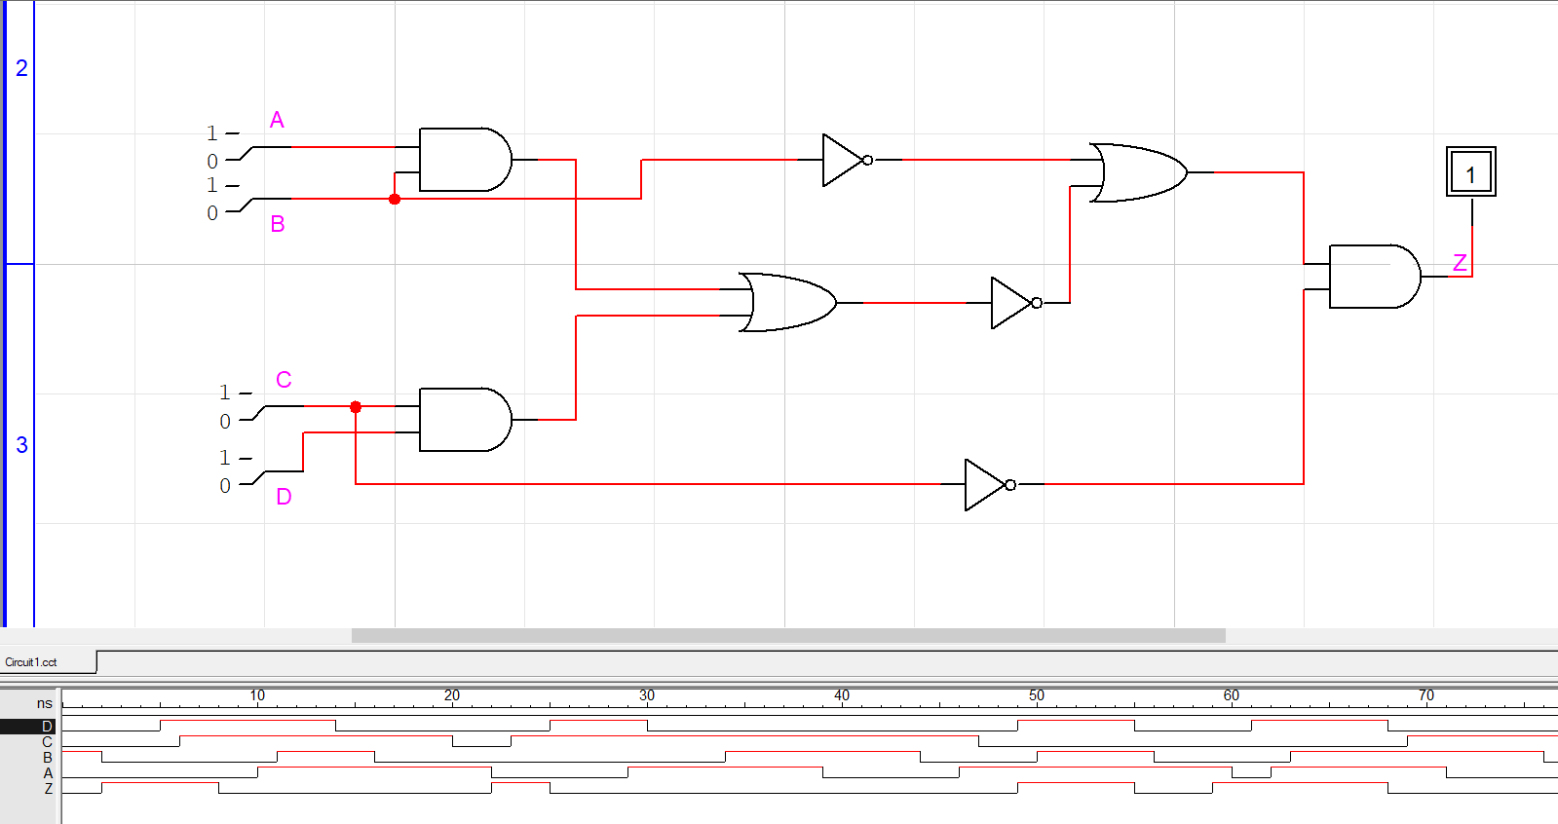

Logic Expression:
Z=(AB’+CD’+B’).C’

Truth table:
A | B | C | D | AB | (AB)’ | CD | (CD)’ | B’ | C’ | Z
0 | 0 | 0 | 0 | 0 | 1 | 0 | 1 | 1 | 1 | 1
0 | 0 | 1 | 0 | 0 | 1 | 0 | 1 | 1 | 0 | 0
0 | 0 | 0 | 1 | 0 | 1 | 0 | 1 | 1 | 1 | 1
0 | 0 | 1 | 1 | 0 | 1 | 1 | 0 | 1 | 0 | 0
0 | 1 | 0 | 0 | 0 | 1 | 0 | 1 | 0 | 1 | 1
0 | 1 | 1 | 0 | 0 | 1 | 0 | 1 | 0 | 0 | 0
0 | 1 | 0 | 1 | 0 | 1 | 0 | 1 | 0 | 1 | 1
0 | 1 | 1 | 1 | 0 | 1 | 1 | 0 | 0 | 0 | 0
1 | 0 | 0 | 0 | 0 | 1 | 0 | 1 | 1 | 1 | 1
1 | 0 | 1 | 0 | 0 | 1 | 0 | 1 | 1 | 0 | 0
1 | 0 | 0 | 1 | 0 | 1 | 0 | 1 | 1 | 1 | 1
1 | 0 | 1 | 1 | 0 | 1 | 1 | 0 | 1 | 0 | 0
1 | 1 | 0 | 0 | 1 | 0 | 0 | 1 | 0 | 1 | 0
1 | 1 | 1 | 0 | 1 | 0 | 0 | 1 | 0 | 0 | 0
1 | 1 | 0 | 1 | 1 | 0 | 0 | 1 | 0 | 1 | 0
1 | 1 | 1 | 1 | 1 | 0 | 1 | 0 | 0 | 0 | 0

